ST. XAVIER’S COLLEGE

**(Affiliated to Tribhuvan University)**

**Maitighar, Kathmandu**



**Computer Graphics**

**Lab Assignment #4**

**SUBMITTED BY:**

**Linus Dhakal**

**013BSCCSIT022**

**SUBMITTED TO**

|  |  |
| --- | --- |
| **Er. Anil K. Sah**  **( Lecturer )** |  |
| **Department of Computer Science** | |

Submission Date: August 18th2015

**STATEMENT: WAP IN C++ Builder to implement BLA Algorithm.**

**ALGORITHM:**

1) Input two points (x1, y1) & (x2, y2).  
2) Determine the differences dx = x2 - x1 and dy = y2 - y1.  
3) Calculate the initial decision parameter P0 = 2dy - dx.  
4) For each xk along the line starting at k = 0,  
   if Pk < 0,  
      a) put a pixel at (xk + 1, yk)  
      b) Pk+1 = Pk + 2dy  
   else  
      a) put a pixel at (xk + 1, yk + 1)  
      b) Pk+1 = Pk + 2dy - 2dx.  
5) Repeat step 4 for dx time.  
6) End

**SOURCE CODE:**

//---------------------------------------------------------------------------

#include <vcl\vcl.h>

#pragma hdrstop

#include "BLA.h"

//---------------------------------------------------------------------------

#pragma resource "*.dfm"

TForm1 *Form1;

//---------------------------------------------------------------------------

__fastcall TForm1::TForm1(TComponent* Owner)

: TForm(Owner)

{

}

//---------------------------------------------------------------------------

void __fastcall TForm1::BLAClick(TObject *Sender)

{

int x1,y1,x2,y2;

x1=StrToInt(Edit1->Text);

y1=StrToInt(Edit2->Text);

x2=StrToInt(Edit3->Text);

y2=StrToInt(Edit4->Text);

int x, y, dx, dy, pk, k, xEnd;

dx=abs(x2-x1);

dy=abs(y2-y1);

if(x1>x2)

{

x = x2;

y = y2;

xEnd = x1;

}

else

{

x = x1;

y = y1;

xEnd = x2;

}

Image1->Canvas->Pixels[x][y]=RGB(255,0,0);

pk=2*dy-dx;

while (x<=xEnd)

{

if(pk<0)

{

x=x+1;

y=y;

pk=pk+2*dy;

}

else

{

x=x+1;

y=y+1;

pk= pk+2*dy-2*dx;

}

Image1->Canvas->Pixels[x][y]=RGB(255,50,50);

}

}

//---------------------------------------------------------------------------

**OUTPUT:**

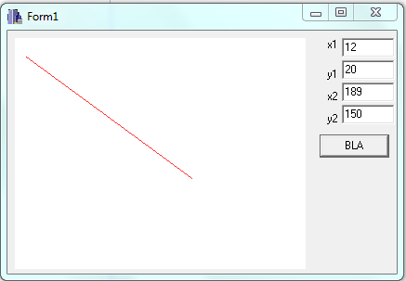

**CONCLUSION:**

Hence, BLA algorithm was implemented and a line was drawn using the above code in C++ Builder.

**REFERENCE:**

**[1]** [**http://www.cs.helsinki.fi/group/goa/mallinnus/lines/bresenh.html**](http://www.cs.helsinki.fi/group/goa/mallinnus/lines/bresenh.html)

**[2]** [**http://samar.techgaun.com/2013/03/bresenham-line-drawing-algorithm.html**](http://samar.techgaun.com/2013/03/bresenham-line-drawing-algorithm.html)

**[3]** [**http://www.cs.bham.ac.uk/~vvk201/Teach/Graphics/Bresenham_derivation.pdf**](http://www.cs.bham.ac.uk/~vvk201/Teach/Graphics/Bresenham_derivation.pdf)